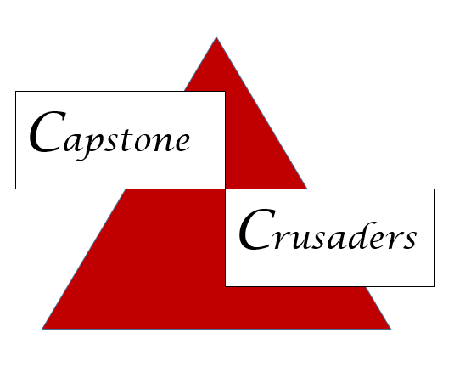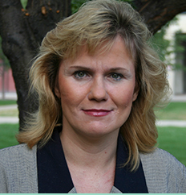

**Clinical Placements**

**Christine Roberts**

**CAA Administrative Assistant**

[**crobert@iu.edu**](mailto:crobert@iu.edu)

**(317) 278-1848**

**Teresa Abney**

**Coordinator, Student Clinical Experiences**

[**tlabney@iu.edu**](mailto:tlabney@iu.edu)

**317 274-3470**

**Megan Siehl, MPA, BA**

**Director, Clinical Placement & Coordination**

[**msiehl@iu.edu**](mailto:msiehl@iu.edu)

**317 278-3634**

**Maggie Burrows**

**Senior Administrative Secretary**

**Onboarding**

[**maburro@iu.edu**](mailto:maburro@iu.edu)

**317 274-7120**

**Paula Reiss, MSN, RN, CEN**

**Capstone Co-Coordinator**

[**preiss@iu.edu**](mailto:preiss@iu.edu)

**Michelle Moore, MSN, RN**

**Capstone Co-Coordinator**

[**mooremil@iu.edu**](mailto:mooremil@iu.edu)

**317 274-5390**

**Onboarding**

**Capstone Coordinators**